

# COURSE MANAGEMENT SYSTEM



**ROLE ALLOCATED:**

* Kuna Aditya and Nisha Gautam: Manual testing
* Manjula M and Emmalla pradeepthi: Development
* Tummidi Raghavendra Rao: Automation testing
* Shivani Yadav: Documentation

**Table Of Content**

* 1. Project Overview -----------------------------------------------------4
  2. Scope --------------------------------------------------------------------6
  3. Features ----------------------------------------------------------------6
  4. Flow Control -----------------------------------------------------------7
  5. User Characteristics--------------------------------------------------9
  6. Advantages-------------------------------------------------------------9
  7. Use Cases detailed---------------------------------------------------10
  8. Sequence Diagram---------------------------------------------------11
  9. Database Entity Relationship Diagram--------------------------12
  10. Specific Requirements----------------------------------------------13
  11. Functional Requirements------------------------------------------14
  12. Technical Detailed Description-----------------------------------18
  13. Performance Requirements---------------------------------------28
  14. Software System Attributes ---------------------------------------29

**1.1 Project Overview:**

Course management system become an integral part of the upper education system. They create teaching and course management easier by providing a framework and set of tools for instructors.

The executive aspects of such systems could include class rosters and therefore the ability to record students’ grades. With relevance to the teaching aspects, however, it might include learning objects, class exercises, quizzes and Tests.

The CMS might also include tools for real-time chat, or asynchronous bulletin board kind communications.

The CMS tool additionally focuses on all aspects of teaching, learning and faculty-student interaction.

In order to form a clear sketch of this project, here’s a brief introduction of the features and scope of Course Management System. This project consists of three modules which are inter-linked to each other. These modules are:

1. Administrator Module
2. Students Module
3. Faculty Module

**1. Administrator Module:** --

Admin can produce accounts for college students and faculties and make course programmed list and add instructors and students to the course list.

**2. Students Module:** --

Student can register with application or the proposed system and login with user name and password. Student will check and submit assignment.

**3. Faculty Module: --**

Faculty can assign work and check student’s assignments and assign grades for assignment.

**1.2 Scope:**

In the existing system, student must visit college and fix the appointment with Faculty.

Only after getting the date and time, student is capable of meeting Faculty within the limited time which may not sufficient to solve all the problems. So, use of computer-based system is obviously more effective and beneficial to both students and Faculty.

This Course Management System is developed with the aim of linking students and Faculties regarding their course activities.

It is used for efficient service in university and faculty and schools in university in each course to access to link e-learning to show course and useful its service.

**1.3 Features:**

The following features of this project have made it more users friendly, efficient and secured.

1. It enables the administrator to provide individual user account to each student and faculty.
2. All the user accounts (faculty and students) are password protected. So, the database can be termed as secured.
3. In Course Management System, only administrative section is allowed to create the account, but students and faculty can register with application.
4. After creating the account, the user can view his/her detail in Database.

**1.4 Flow Control:**

* **Product Perspective: --**The system will be operated within university environment. This environment has another system that will interact with this system so we need interfaces between this system.

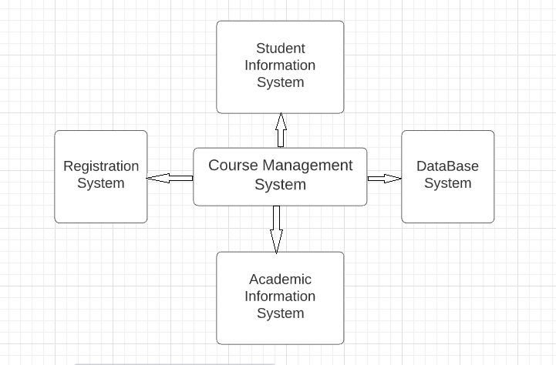

* **Product Function: --**

1. The system shall be able to Create Courses.

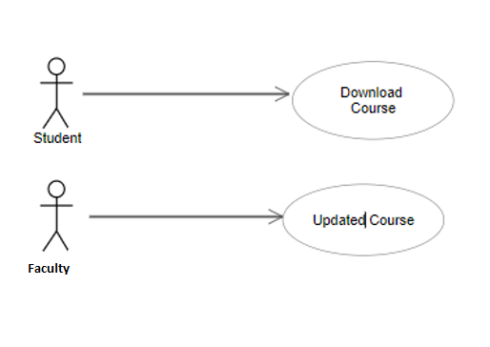

1. The system shall be able to automatically create accounts for students and faculty.
2. The system shall be capable of Managing Student Grades.

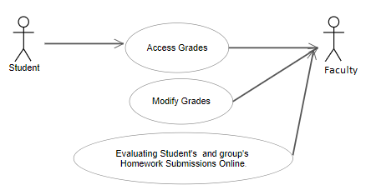

1. The system shall be capable of automatically accepting assignment Submissions.

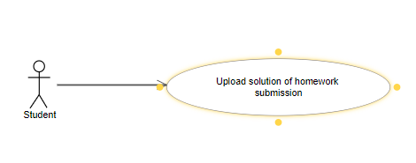

**1.5 User Characteristics:**

The student expected to be Internet literate once he/she can log in the system and navigate between Webpages he/she can use basic functionality of the system.

Faculty expected to be internet literate and to be able use more complex functionality of the system.

* 1. **Advantages:**
* The automated system is time-saving and better performance than the manual based system.
* Students are encouraged to think critically & support their opinions.
* Students who excel in online class develop a system for keeping track of upcoming assignments due dates.
* There are no traffic jams, parking hassles are adverse weather conditions it enables the students to access course materials & contributed to discussion boards.
* Home comfort.
* Cost savings and Schedule flexibility.

**1.7 Use Cases detailed:-**

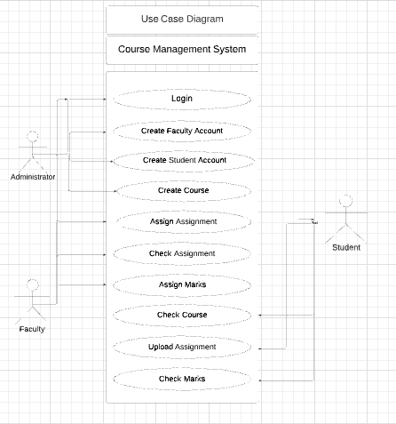

**1.8 Sequence Diagram:**

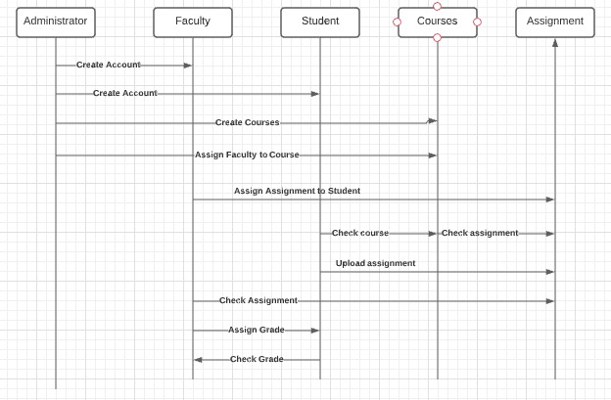

**1.9 Database Entity Relationship Diagram:**

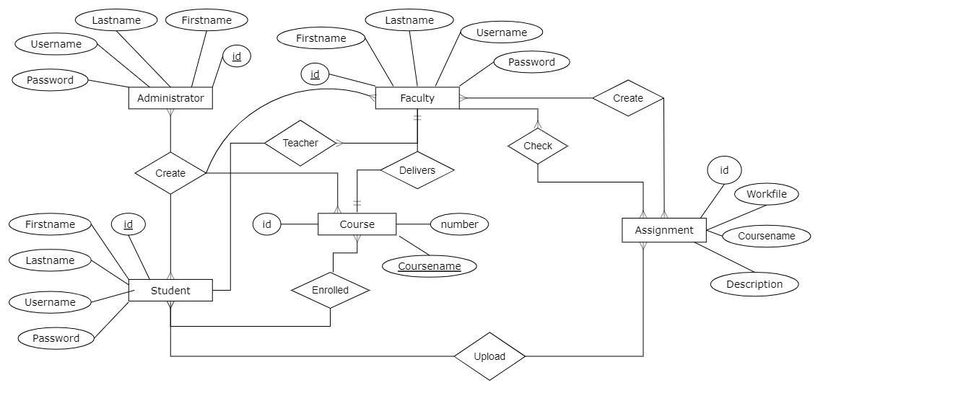

**1.10 Specific Requirements:**

1. **External Interface Requirement**
2. User Interfaces

It must interface icons or wizard.

1. **Hardware Interfaces**

It’s must be pc computer to link to course management system.

1. **Software Interfaces**

We must internet explorer to able to browser and show and interest course management system.

1. **Communication Interfaces**

We must user interface rather command line.

**1.11 Functional Requirements:**

* **Creating Courses**

1. Integration with registration system: The system shall periodically upload the latest register’s classes list to determine courses that offered in the current semester

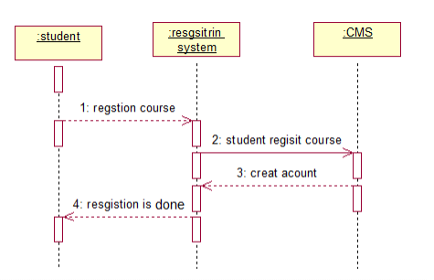

1. The system shall generate course for each class that registered and determine the current set of students that enrolled in that class.
2. The system shall allow course instructor to update course content.

* **Grade Management**

1. Allow grades to be entered: The system shall allow instructors to enter and modify grades.
2. Allow students to access their grades: The system shall allow student to log into their account and check their grades at any time.
3. The system shall provide statistical information such as averages, standard deviation, median about students’ grades.
4. Track and Handle Re-grade Requests: The system shall be able to track and handle requests for re- grades, and all information about re-grades shall be available to the student, and the course instructor.

* **Assignment Submissions**

1. Accept submissions in multiple formats: The system shall accept submissions in multiple formats, including .zip, .txt, .doc, etc.
2. Support for late submissions: The system shall provide information about late submissions, and also disallow submissions after a certain period of time.

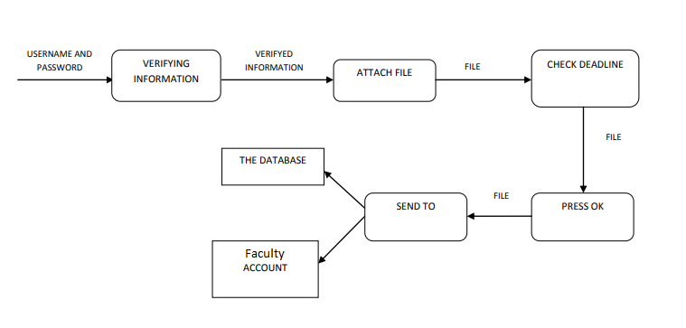

1. Integration with grade management: The assignment submission system shall be integrated with the grade management by using grading templates that can be filled out, and automatically annotating code with line numbers.
   1. Assignment grades can be automatically posted to student account.

* **Create Accounts:**

1. The system shall automatically create accounts for each class.
   1. Create one account for course instructor regardless to the number of classes that he/she teach.
   2. The account username is course name and its number.
   3. The account password is the same password that in AIS.
   4. Any change in the password in AIS the system shall reflect it on the instructor account password in CMS.
   5. Create one account for each student that registered in this class.
   6. The account username is course name and its number.
   7. The account password is the same password that in SIS.
   8. Any change in the password in SIS the system shall reflect it on the student account password in CMS
   9. Any change in the password in AIS the system shall reflect it on the instructor account password in CMS.
   10. Create one account for each student that registered in this class.
   11. The account username is course name and its number.
   12. The account password is the same password that in SIS.
   13. Any change in the password in SIS the system shall reflect it on the student account password in CMS.

2. Faculty account contain the classes that he/she teach, each class contain list of student that ordered based on student serial number.

3. Faculties can modify student grades from his/her account.

**1.11Technical Detailed Description:**

**GitHub Link** <https://github.com/Raghava1317/Course-Management-System>

1. **Administrator Account**

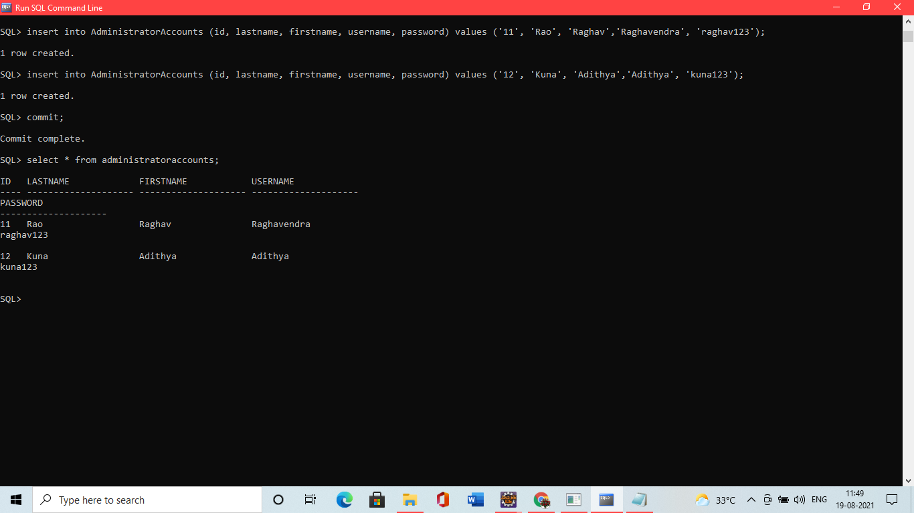

1. **Administrator creating account for students and record inserted**

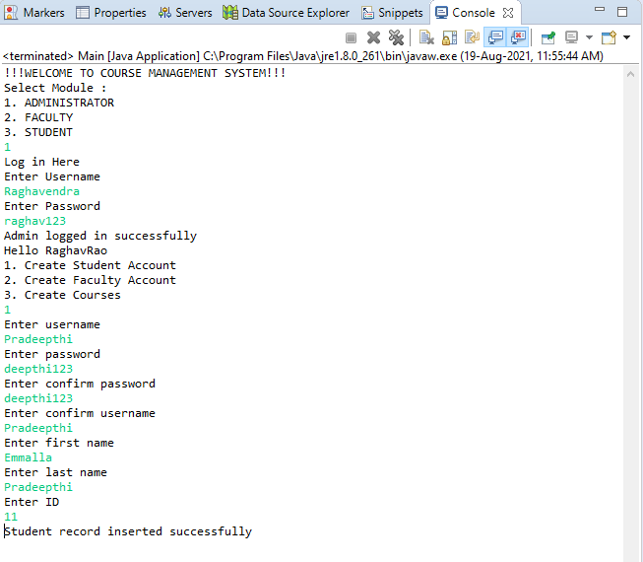

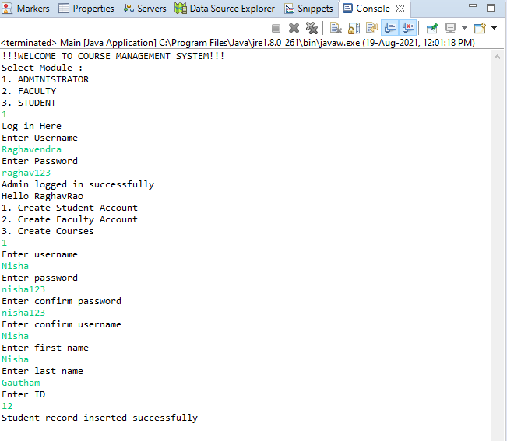

1. **Student Account**

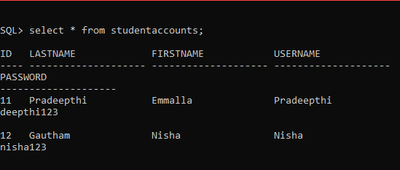

1. **Administrator creating account for faculty and record inserted.**

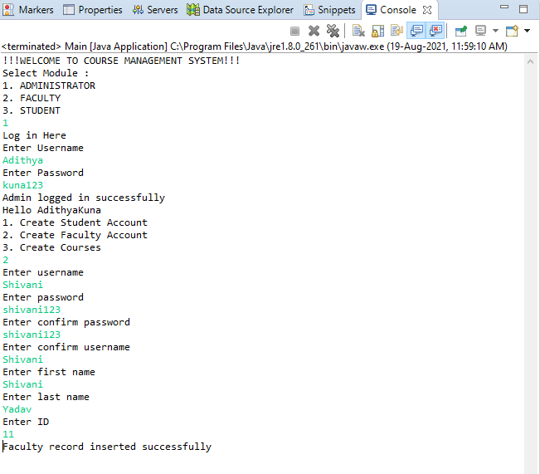

1. **Faculty Account**

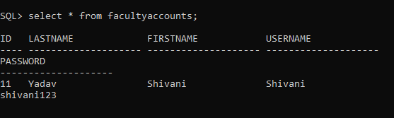

**6. Administrator creating courses and record inserted.**

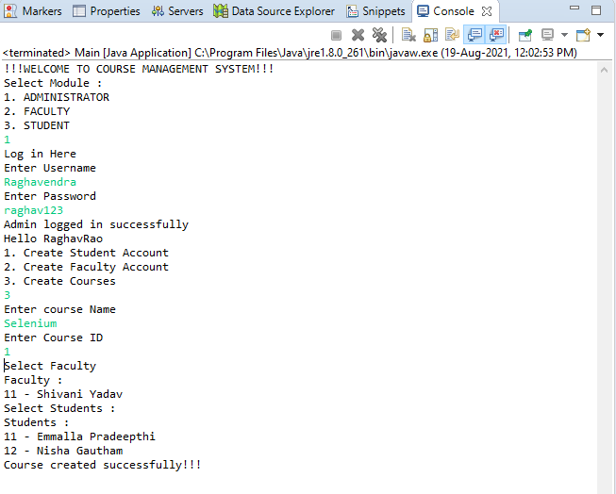

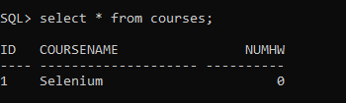

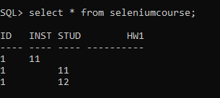

**7. Faculty Assigning work for Student**

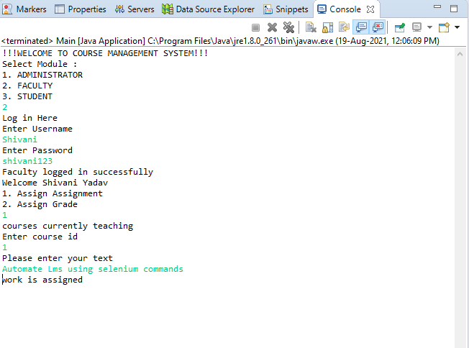

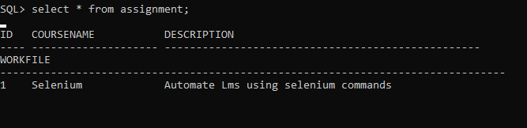

**8. Student checking for the course**

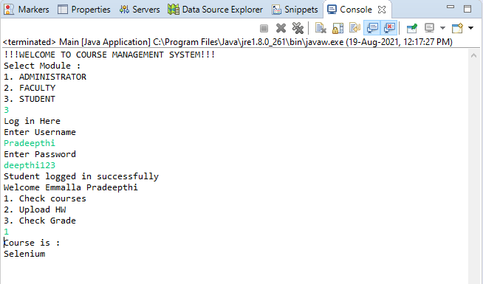

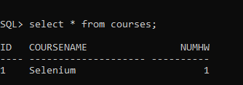

**9. Student Uploading assignment**

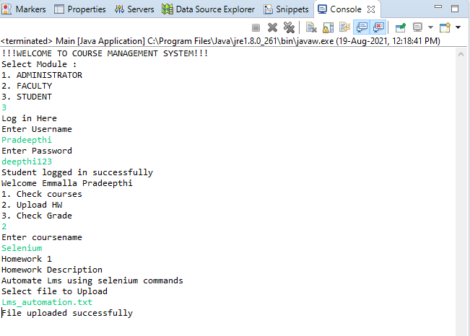

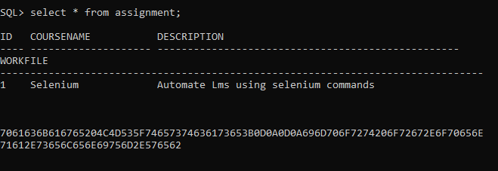

**10. Faculty assigning Grade**

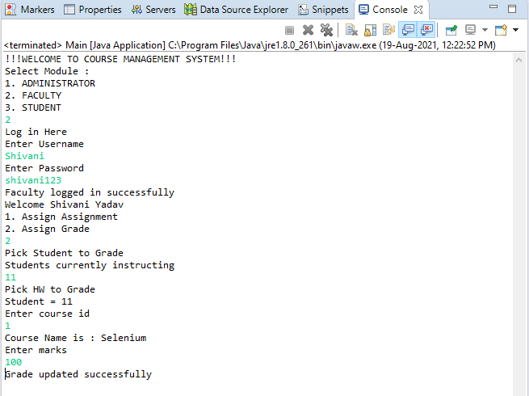

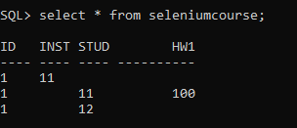

**11.Student checking grade**

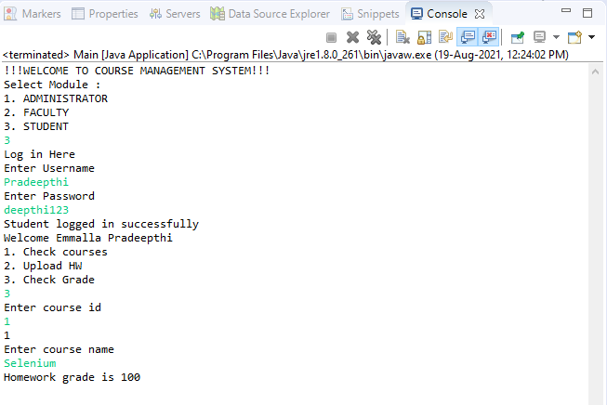

* 1. **Performance Requirements:**

1. **Response Time**

Average response time shall be less than 2 second.

1. **Throughput**

The system shall accommodate 1000 booked per minute.

1. **Recovery Time**

In case of a system failure, redundant system shall resume operations within 30 seconds. Average repair time shall be less than 1 hour.

1. **Start-up/Shutdown Time**

The system shall be operational within 1 minute of starting-up.

1. **Capacity**

The systems accommodate 4000 concurrent users.

1. **Utilization of Resources**

The system shall store in the database no more than one million transactions. If the database grows over this limit, old transaction shall be backed up and deleted from the operational database.

* 1. **Software System Attributes:**

1. **Security**
   1. Firewall Protection: The course management software system shall run inside a firewall.
   2. Support different roles: The system shall support different roles for users, such as Instructors, Students, and administrative staff, the user logged in with given role should only be allowed access consistent with that role. For example a student shall only be allowed to see he/she grades not to modify it.
2. **Reliability**

The system shall not be down more 2 times in year.

1. **Scalability**

Scaling system to large number of users: large courses will have hundreds of students.

The system shall be able to handle the load for such courses, especially near assignment deadlines when many students can be expected to access the course management system.